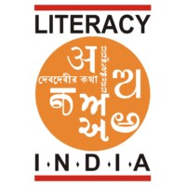

Limited seats

Register Now

gg

[WWW.Literacyindia.org](http://WWW.Literacyindia.org)

Session Starts from

January 2024

Contact no-8588853380

Contact no- 8588853380

LITERACY INDIA COMMUNITY COLLEGE

Transforming lives.

Building Resilient Communities.

Programs Offered

* Robotics/Tinkering
* Computer Hardware
* Mobile Repairing
* Cooking/Hospitality
* Beauty & wellness
* Stitching & Cutting
* Electrical Troubleshooting
* Two-Wheeler Repairing
* Mobile Journalism
* Computer Science
* Call Centre/BPO
* Logistics
* Data Digitization
* Natural Farming Market Connect
* Banking

D